Convolutional Neural Network (CNN)

ROAD SIGNS CLASSIFICATION

Name: Anushiya S

Batch: DADS Online

Year: March 2025
INTRODUCTION
A Convolutional Neural Network (CNN) is a specialized type of deep learning model within machine learning, primarily designed for processing data with a grid-like topology, such as images, videos, and sometimes even text or audio.
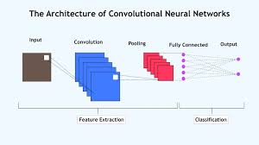

PROJECT DESCRIPTION
Convolutional Neural Networks (CNNs) are widely used in machine learning for road sign classification due to their effectiveness in image analysis tasks. The process typically involves several key steps
- Data Collection and Preprocessing:
- CNN Model Architecture:
- Model Training:
- Evaluation and Prediction

WORKING ON THE DATASET (IMPORT LIBRARIES)
import os
import numpy as np
import pandas as pd
import matplotlib.pyplot as plt
from sklearn.model_selection import train_test_split
from tensorflow.keras.utils import to_categorical
from tensorflow.keras.preprocessing.image import ImageDataGenerator
from tensorflow.keras.models import Sequential
from tensorflow.keras.layers import Conv2D, MaxPooling2D, Flatten, Dense, Dropout, BatchNormalization
from tensorflow.keras.callbacks import EarlyStopping, ModelCheckpoint
import cv2
from tqdm.notebook import tqdm
- COLLECTING THE DATASET
Images: The road sign images that is classified into folders
Data
Test
”Label.CSV” has been uploaded from
Label: 30 classes or categories of road signs (e.g., speed limit, stop sign).
Total Classes Detected: 30
✅ CSV loaded successfully!
Columns: ['Class Id', 'Name']
Class Id Name
0 0 Speed limit (5km/h)
1 1 Speed limit (15km/h)
2 2 Speed limit (30km/h)
3 3 Speed limit (40km/h)
4 4 Speed limit (50km/h)

- DATA PREPROCESSING AND IMAGE AUGMENTATION
- Images are preprocessed, which may include resizing, converting to grayscale, applying histogram equalization for contrast enhancement, and normalizing pixel values.
- Data augmentation techniques like rotation, shifting, and zooming are often used to increase the diversity of the training data and improve the model's generalization.
- Creating an ImageDataGenerator object with augmentation parameters
Data preprocessing cleans and transforms raw data into a usable format.
✅ Loaded images: (743, 64, 64, 3)
✅ Loaded labels: (743,)

- BUILD CNN MODEL



- COMPILE THE MODEL
Model. Compile-optimizer= 'Adam'
- Conv2D (32 filters) — The model looks at the image and starts finding basic shapes like lines or edges.
- MaxPooling2D — It then shrinks the image a bit, keeping only the important parts.
- Conv2D (64 filters) — Now it learns more detailed patterns, like circles or corners of symbols.
- MaxPooling2D — Again, it reduces the size so the model can learn faster.
- Flatten — It flattens the image data (turns it into a list of numbers).
- Dense(128) — This layer thinks about all the features and learns patterns to make a decision.
- Dropout(0.5) — It drops some connections randomly while training to avoid overfitting (so the model doesn’t just memorize).
- Dense(..., softmax) — The final layer gives the probability for each class, like “Stop”, “Speed Limit”, or “No Entry”.

- TRAIN THE MODEL
history = model.fit(X_train, y_train, epochs=15, validation_data=(X_val, y_val), batch_size=64)

accuracy: 0.9262 - loss: 0.3546
✅ Validation Accuracy: 92.62 %

- EVALUATE MODEL
test_loss, test_acc = model.evaluate(test_ds)
print("Test accuracy:", test_acc)
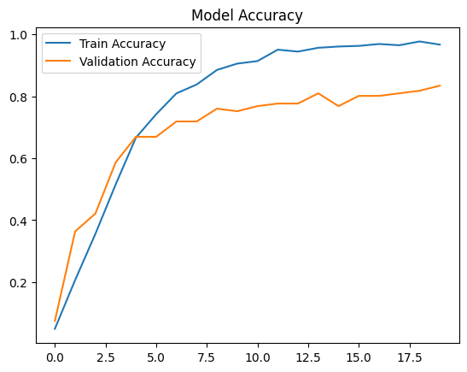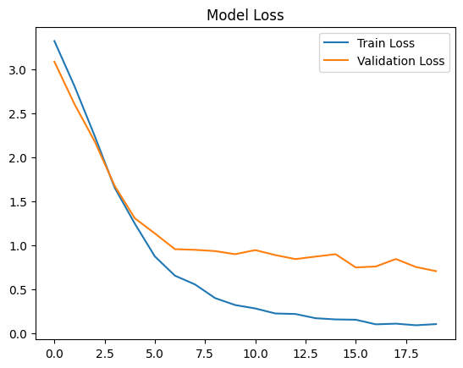

- CONFUSION MATRIX FOR ROAD SIGN CNN
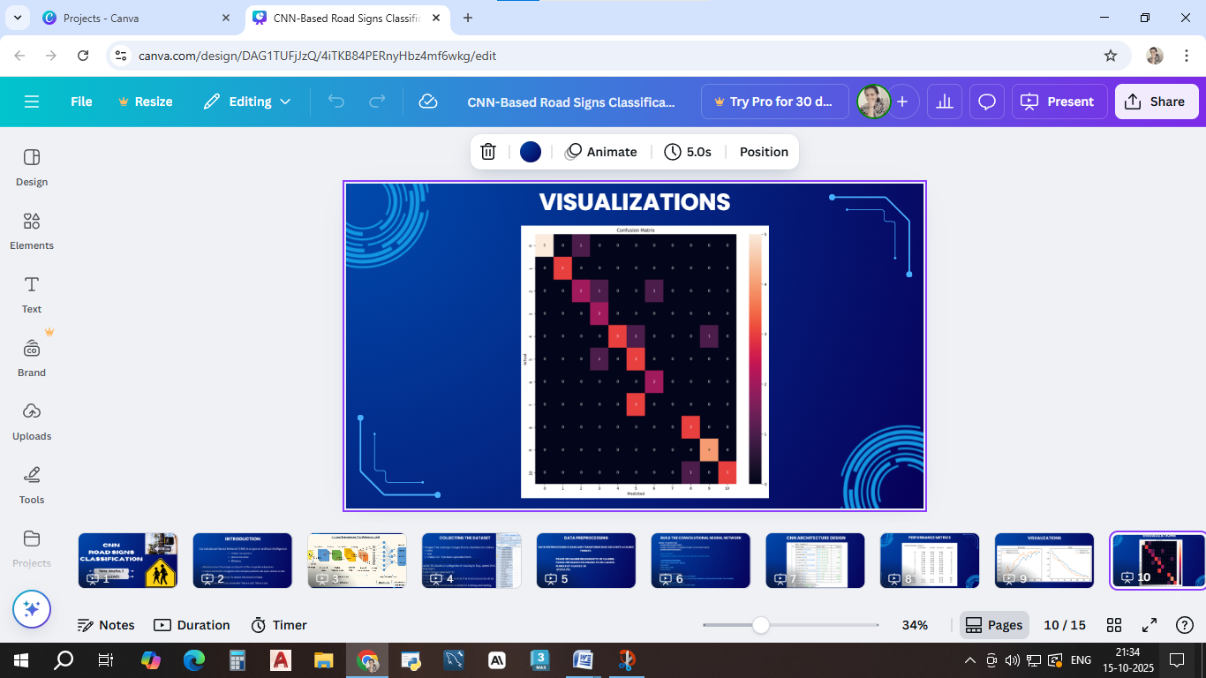

- STREAMLIT

- A Graphical User Interface (GUI) was developed using Streamlit to make the trained CNN road sign classification model interactive and user-friendly.

- The interface allows users to upload road sign images, visualize them, and instantly view the model’s predictions along with the accuracy score.

- The Streamlit app integrates the trained CNN model (road_signs_cnn_model.h5) and label file (Road Sign Classification.csv).

- When a new image is uploaded, it is preprocessed (resized and normalized), passed into the model, and the predicted class name and confidence level are displayed clearly.

- VISUALIZE RESULTS
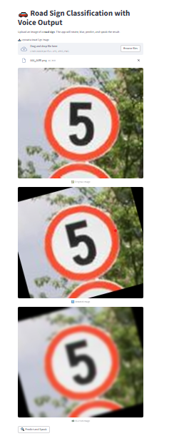
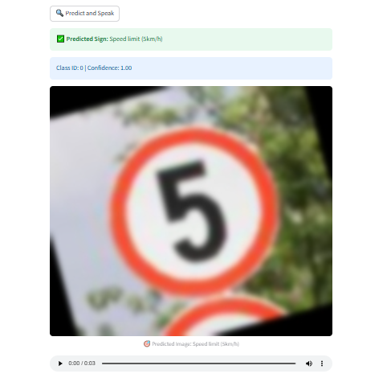

- INSIGHTS

- The CNN-based model effectively learned to recognize and classify various road signs with high accuracy.

- Data augmentation improved the model’s ability to handle variations such as rotation, brightness, and scale.

- The Streamlit interface made the model interactive, allowing real-time testing with new images.

- The project demonstrates how deep learning can be applied to enhance intelligent transportation and driver-assistance systems.

- FUTURE SCOPE

- The system can be extended to perform real-time road sign detection using live video feeds from vehicle cameras.
- Incorporating voice alerts or driver-assistance notifications can enhance safety applications.
- Expanding the dataset to include different countries’ traffic signs will make the system globally applicable.

- CONCLUSION

The CNN-based Road Sign Recognition system successfully identified and classified traffic signs with high accuracy.
The trained CNN model effectively captured essential visual features such as shapes, colors, and patterns of road signs.

THANK YOU
Name: Anushiya S
Batch: DADS Online
Year: March 2025

